Deep Learning Techniques for Breast Cancer Risk

Prediction using IBM Cloud

# INTRODUCTION

## Overview

Breast cancer is a dominant cancer in women worldwide and is increasing in developing countries where the majority of cases are diagnosed in late stages. The projects that have already been proposed show a comparison of machine learning algorithms with the help of different techniques like the ensemble methods, data mining algorithms or using blood analysis etc. This paper proposed now presents a comparison of six machine learning (ML) algorithms: Naive Bayes (NB), Random Forest (RT), Artificial Neural Networks (ANN), Nearest Neighbour (KNN), Support Vector Machine (SVM) and Decision Tree (DT) on the Wisconsin Diagnostic Breast Cancer (WDBC) dataset which is extracted from a digitised image of an MRI. For the implementation of the ML algorithms, the dataset was partitioned into the training phase and the testing phase. The algorithm with the best results will be used as the backend to the website and the will then classify the cancer as benign or malignant.

## Purpose

Machince learning is one of the most popular models to easily train machines and create predictive models for

successful decision-making. Machine learning helps with early diagnosis of breast cancer and determines the nature of the cancer by analysing the tumour size. ML methods are the leading approaches to obtain favourable outcomes among classification and prediction problems. Breast cancer research could benefit from ML techniques used to identify cancer and predict the presence or absence of tumours.

# LITERATURE SURVEY

The role various modalities in breast imaging by Sachin Prasad N and Dana Houserkova, 2007. Mammography is the only reliable screening test proven in breast imaging.

Identification of Preprocessing Technique for Enhancement of Mammogram Images by Jaya Sherma, R P Tewari and J K Rai, 2014.

Determining best preprocessing technique on the basis of peak signal to noise ratio for set of mammogram images.

Classification of Mammogram Images by using CNN Classifier by Ketan Sharma and Bobbin Preet, 2016. In this paper they proposed a computer aided diagnosis(CAD) system named as CNN. . They had also compared of CNN with Logistic Regression algorithm.

# THEORITICAL ANALYSIS

## Block Diagram

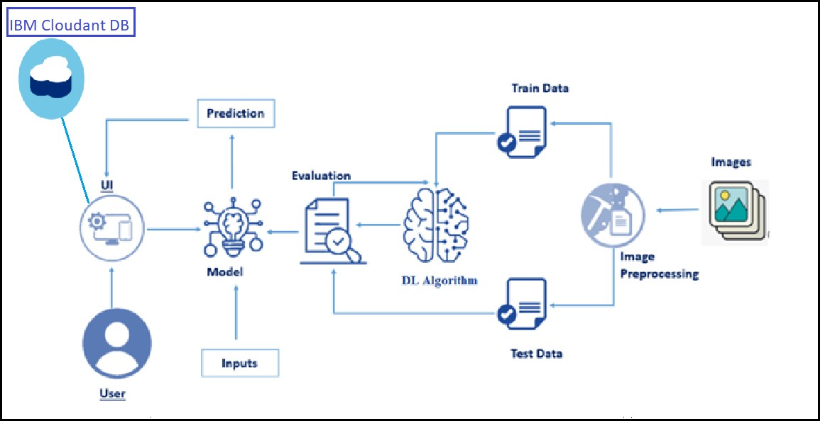

* 1. **Hardware / Software designing**

### Software Requirements:

* + - Anaconda Navigator
    - Tensor flow
    - Keras
    - Flask

### Hardware Requirements:

* + - Processor : Intel Core i3
    - Hard Disk Space : Min 100 GB
    - Ram : 4 GB
    - Display : 14.1 “Color Monitor(LCD, CRT or LED) Clock Speed : 1.67 GHz

# EXPERIMENTAL INVESTIGATIONS

Study shows that it provide with different test images of breast cancer images, the model detects, cost prediction of uploaded image. When we choose an image and click in to the upload it then it will shows the predicted output.

1. **RESULT**

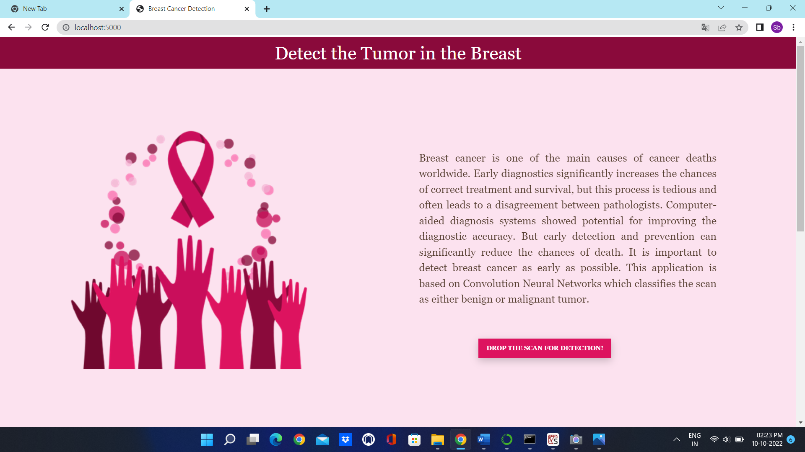

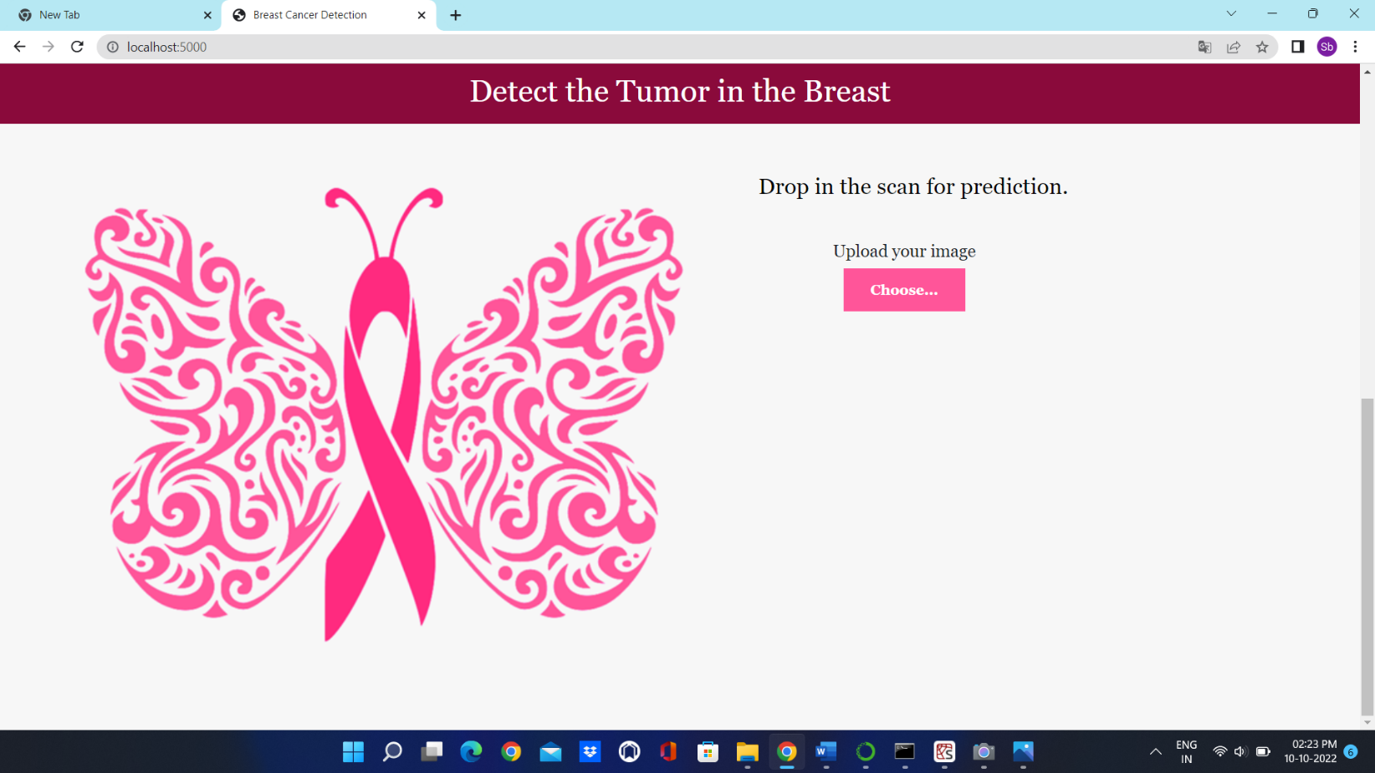

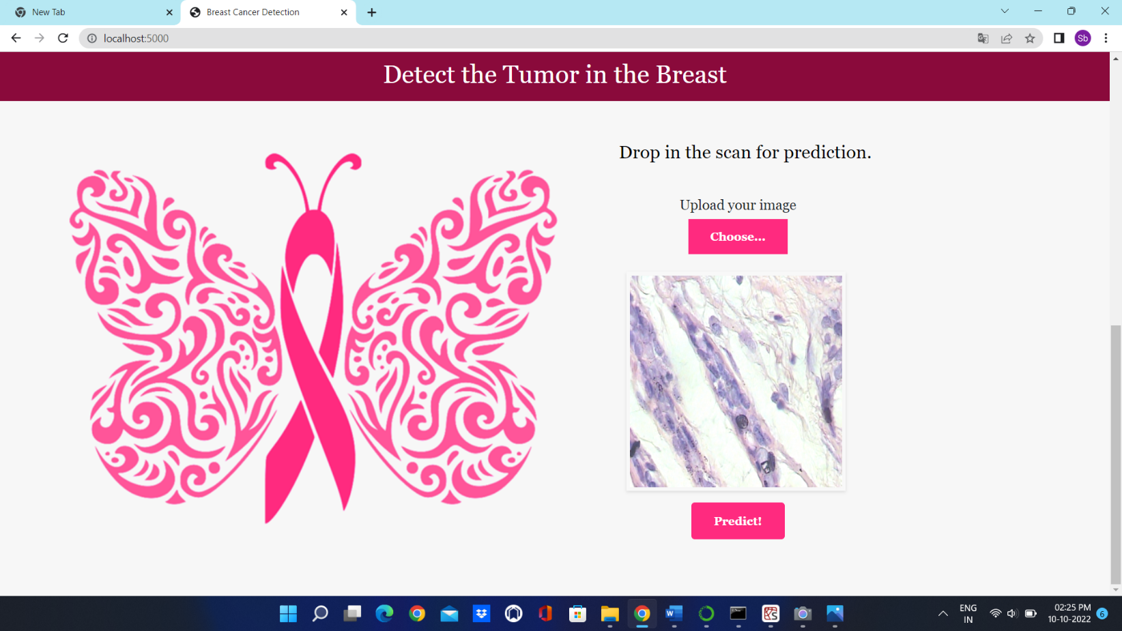

# ADVANTAGES & DISADVANTAGES

### Advantages:

* Increased accuracy for insurance prediction.
* Reduce the time complexity.

### Disadvantages:

* Data mining techniques does not help to provide effective decision making.

# APPLICATIONS

* Deep Learning technology is considered as one of the key technology used in breast cancer detection.
* It presents the results obtained by processing input from uploading image.

# CONCLUSION

In this project, we have established the application to predict from uploaded image based on the IBM cloud application. Breast cancer prediction can only use this web app to predict the cancer.

# FUTURE SCOPE

The analysis of the results signifies that the integration of multidimensional data along with different

classification, feature selection and dimensionality reduction techniques can provide auspicious tools for

inference in this domain. Further research in this field should be carried out for the better performance of the

classification techniques so that it can predict on more variables. We are intending how to parametrize our

classification techniques hence to achieve high accuracy. We are looking into many datasets and how further

Machine Learning algorithms can be used to characterize Breast Cancer. We want to reduce the error rates

with maximum accuracy

## APPENDIX

**Source Code**

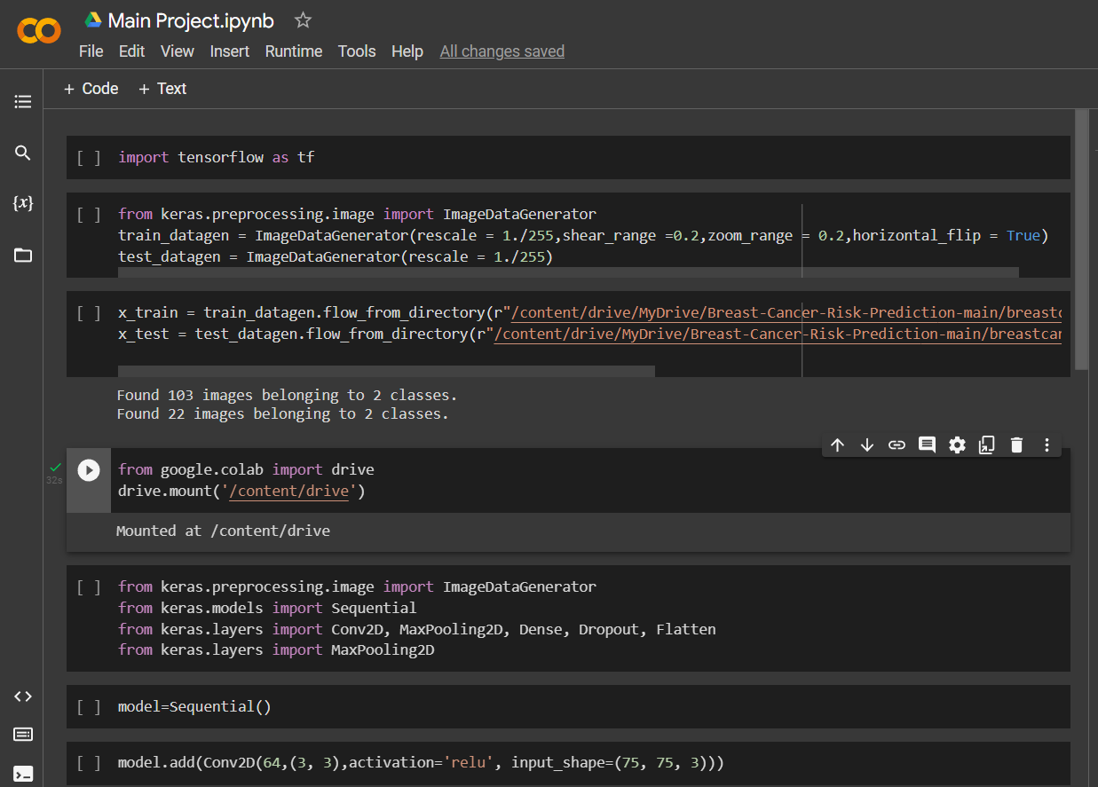

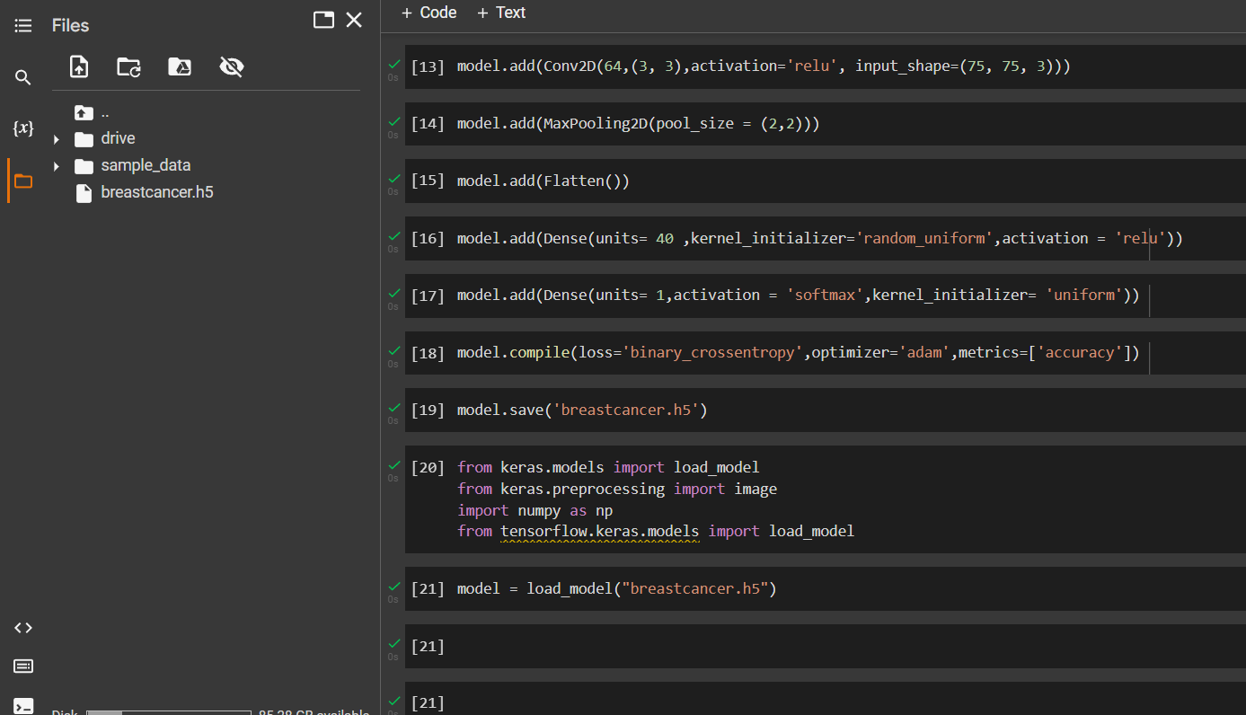

Training Model:

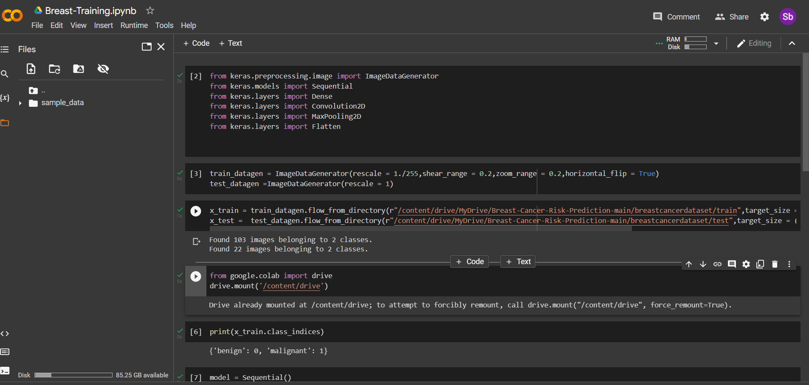

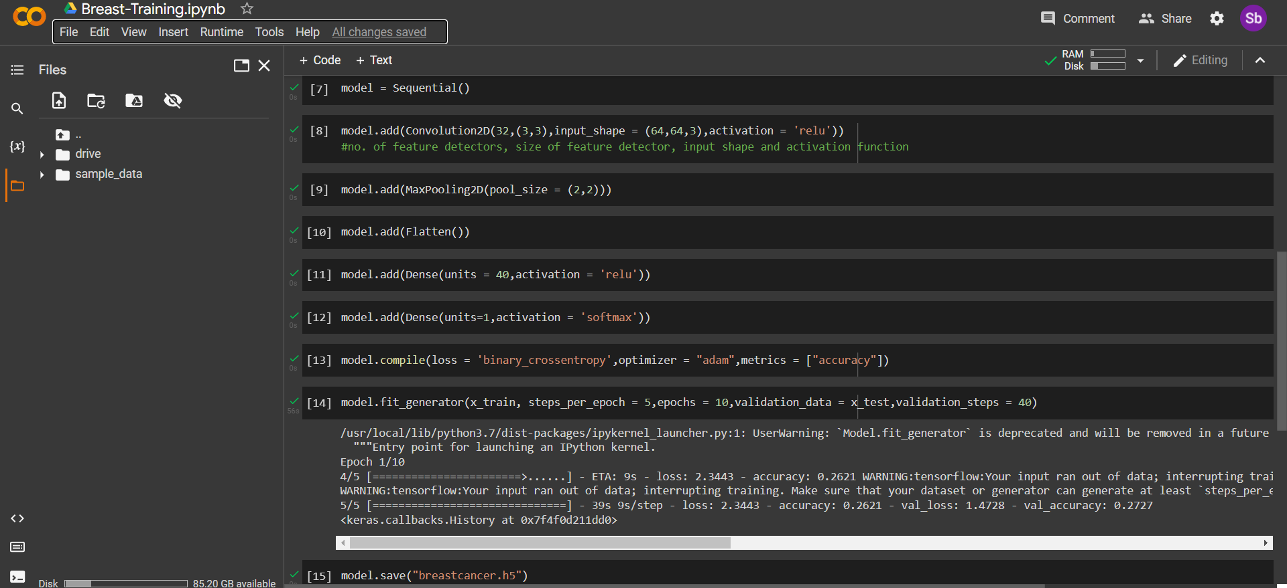

Testing Model:

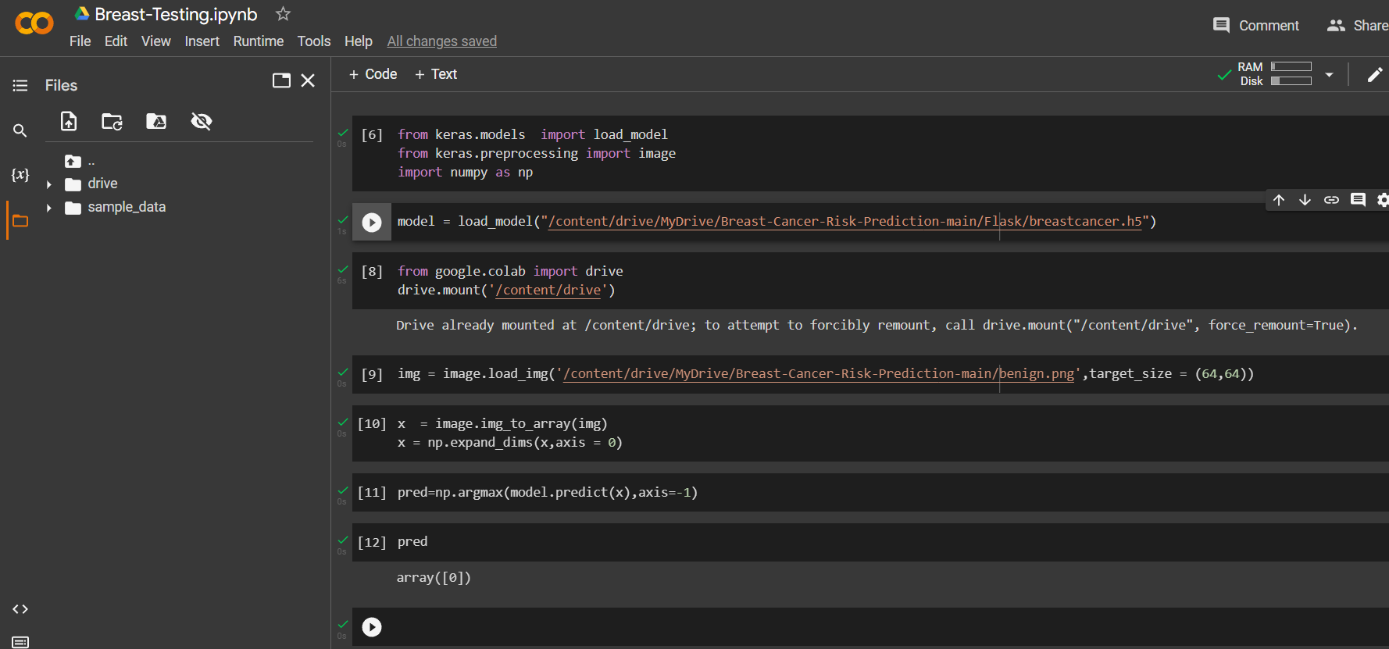

Interface: App

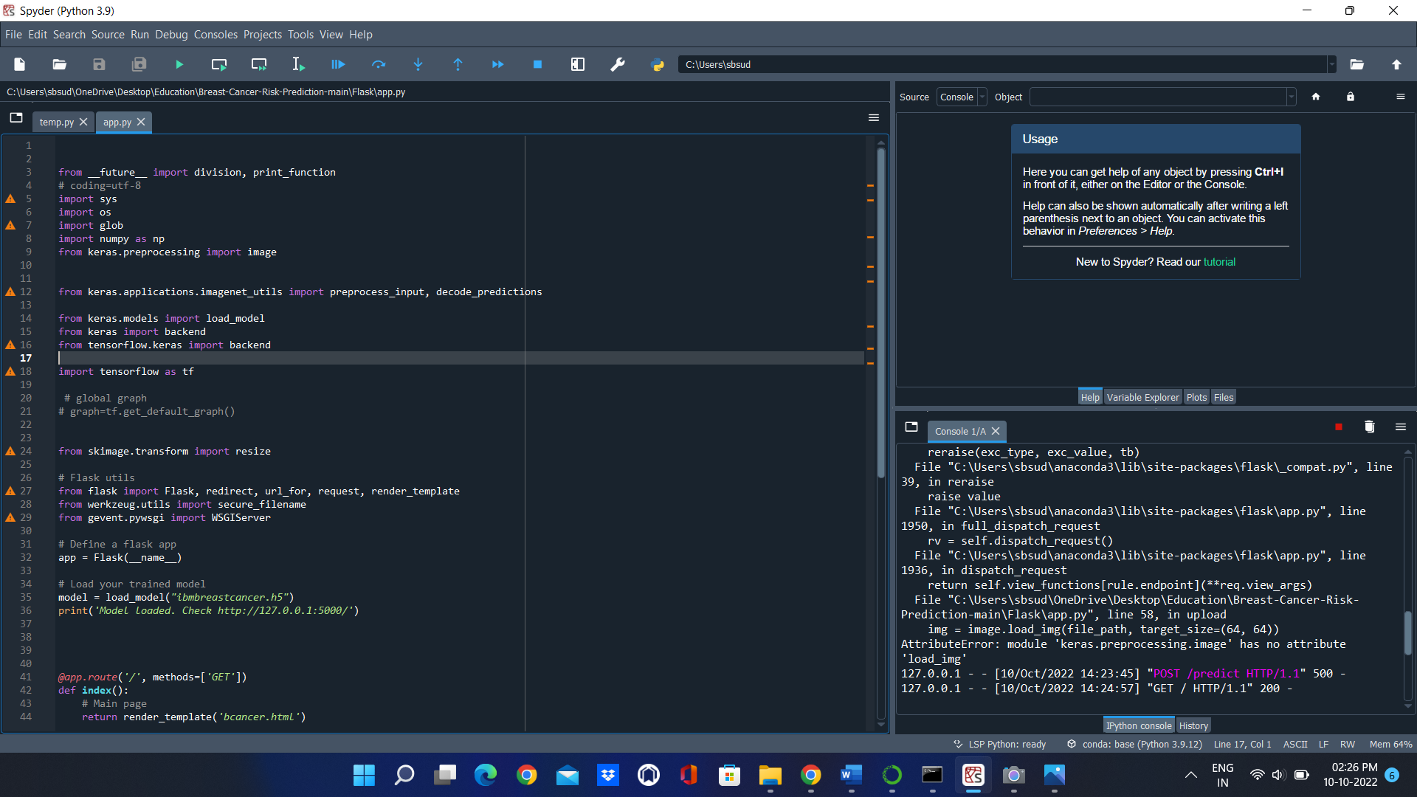

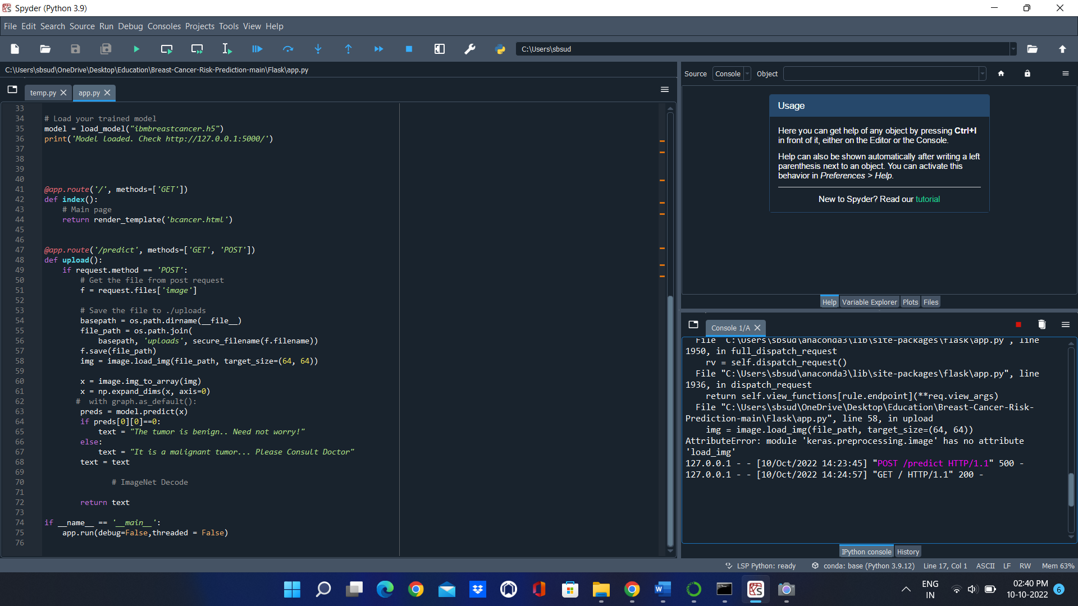

Output:

